# 

**British University College**

COS-103 (Database Application)

Assignment

**Student ID : 00557**

**Name : Aung tun Lin**

**Submission Date** : December 9, 2022

Contents

1

**What is MySQL?** 3

**Task1-Entity Relationship Diagram(ERD)** 4

Including Multiplicity and Cardinality 4

**Task2-SQL :DDL&DML** 5

Introduction to DDL 5

**Table Creation** 6

1.Aeroplane: 6

2.Technician: 7

7

3.Technician Support: 7

4.Mtype: 7

5.Maintenance 8

6.Maintenance Technician 8

7.Pilot 8

8.AssessmentType 9

9.AssessmentTrans 9

10.AssessmentRecord 9

11.Aerofly 10

12.PilotAerofly 10

**Data inserting**: 11

Inserting Data into Aero plane 11

Inserting Data into Technician Tables 12

Inserting Data into Technician Support Table 13

Inserting Data into M type Table 14

Inserting Data into Maintenance Table 15

Inserting Data into Maintenance Technician Table 16

Inserting Data into Assessment Type Table 17

Inserting Data into Assessment Trans Table 19

Inserting Data into Pilot Table 20

Inserting Data into Assessment Record Table 21

Inserting Data into Aero fly Table 22

Inserting Data into Pilot Aero fly Table 23

Data Selection: 24

Task 3 – Relational Algebra: 25

# **What is MySQL?**

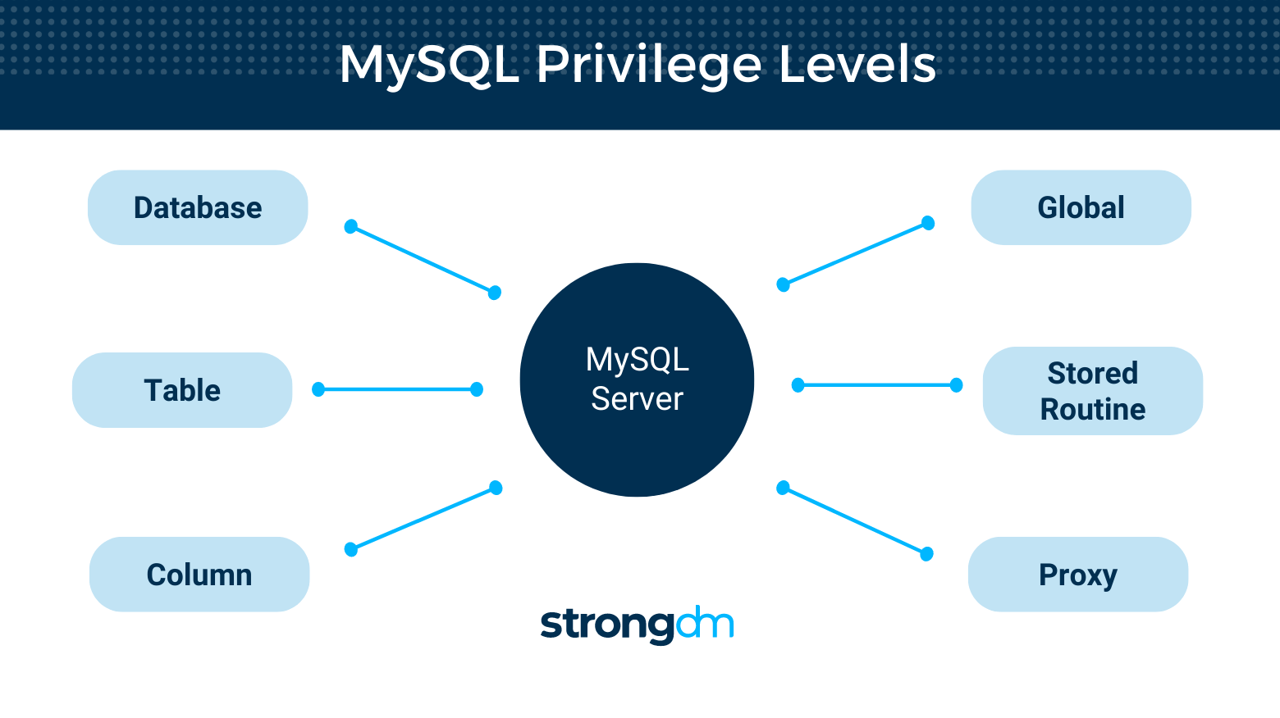The most widely used Open-Source Relational SQL database management solution is called MySQL. One of the greatest RDBMSs for creating web-based software applications is MySQL. It will get a head start with MySQL and gain confidence in MySQL programming with the help of this lesson. A relational database system may be interacted with using the structured query language, or SQL, which is maintained as an ISO standard. In order to design, maintain, and query data in a database, SQL offers a practical degree of abstraction. Unlike imperative programming languages like the C programming language, where all computations are clearly specified step-by-step, SQL is a declarative programming language.

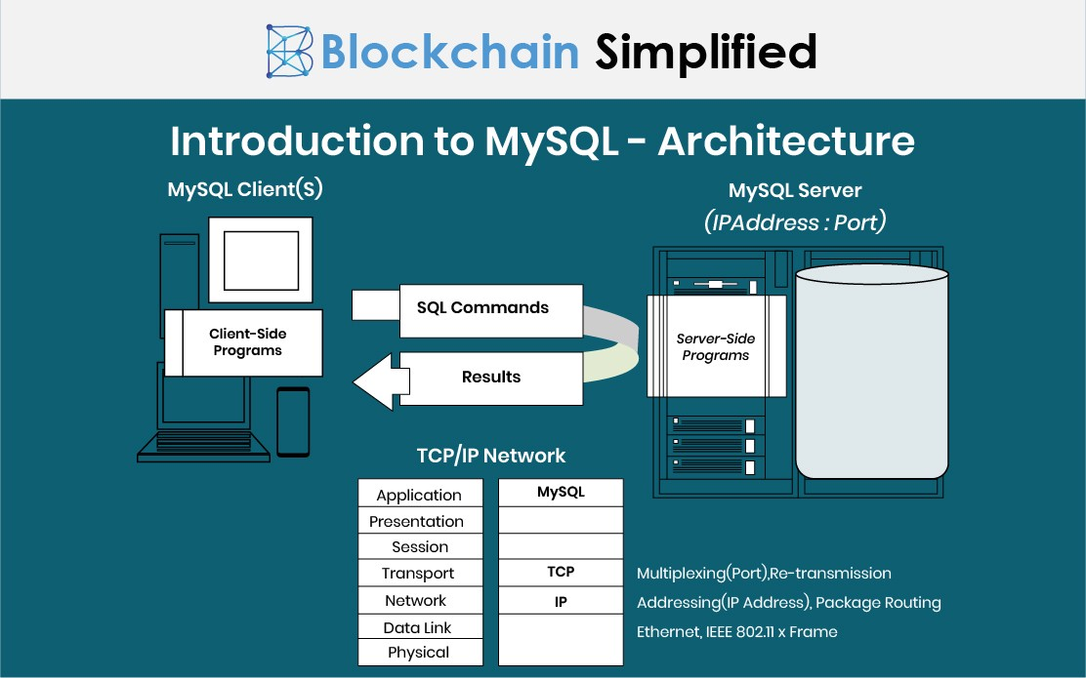

# **Task1-Entity Relationship Diagram(ERD)**

## Including Multiplicity and Cardinality

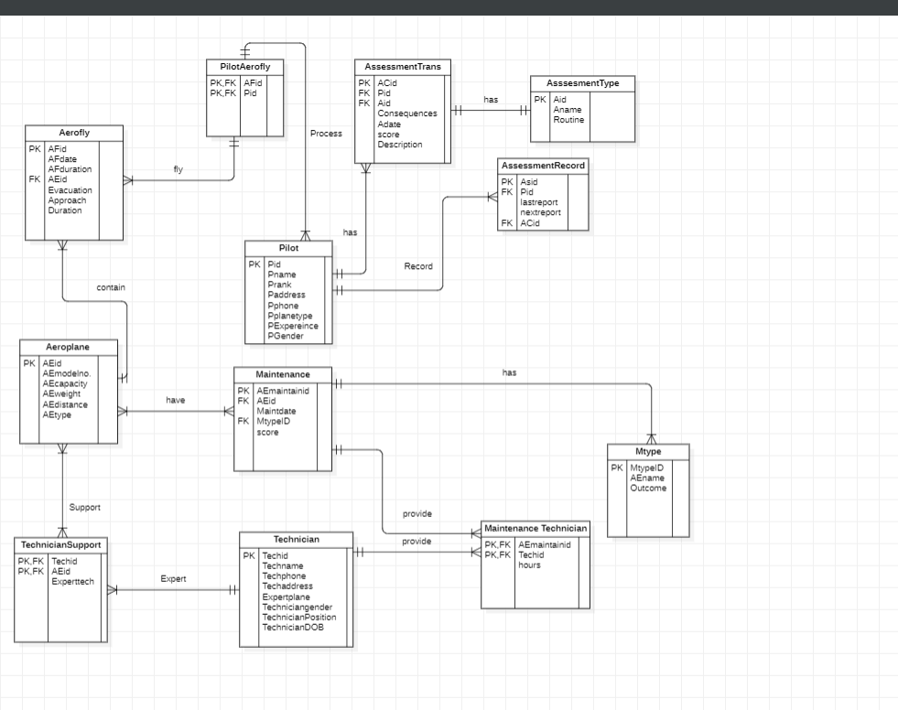

# **Task2-SQL :DDL&DML**

## Introduction to DDL

The word DDL stands for Data Definition Language. The DDL Language used to define and change the structure and data. It is used to create and alter the database's table and other object structures. DDL Commands are as follows:

* CREATE
* DROP
* ALTER
* RENAME &
* 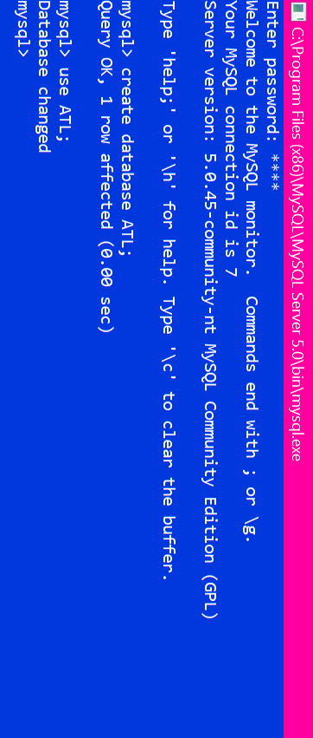TURNCATE

The above snapshot represents the request of password that user must put the correct one to proceed the following. The above command line “Create” is used to create a database along with the new name-ATL. Then use the database name that used while creating a new database.

# **Table Creation**

## 1.Aeroplane:

This is the creation of Aero Plane Table where Field, Type and Primary key is used.

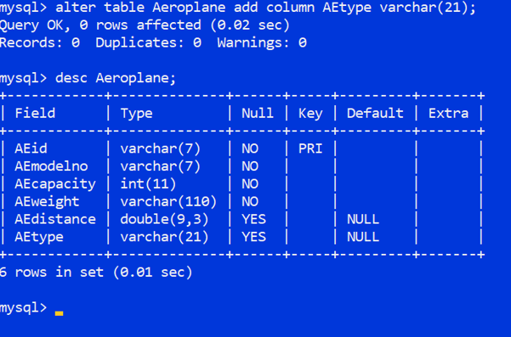This is the display of Aero Plane table consist of six different attributes.

## 2.Technician:

## 

## 3.Technician Support:

This is the Display of Technician Support consist of three attributes with the two primary key along to the table.

## 4.Mtype:

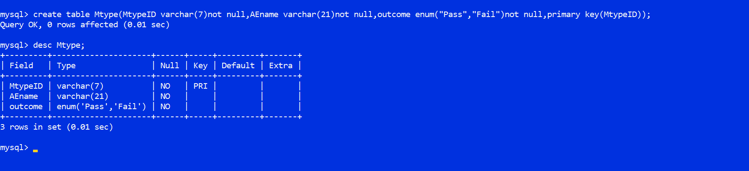Above this snapshot represents the Maintenance type creation table with the three field name where one field name consist of primary key.

## 5.Maintenance

This is the Maintenance Table consist of five field names with different Type along with the foreign key and Primary key.

## 6.Maintenance Technician

This is the Maintenance Technician table that has three attributes along with primary key and Foreign Key as shown in the picture

## 7.Pilot

This snapshot contain Pilot table with the eight attributes along with the primary key in Pid.

## 8.AssessmentType

## 9.AssessmentTrans

This is the Assessment Transmission Table contain its related attributes with the concern primary key and foreign key from another table.

## 10.AssessmentRecord

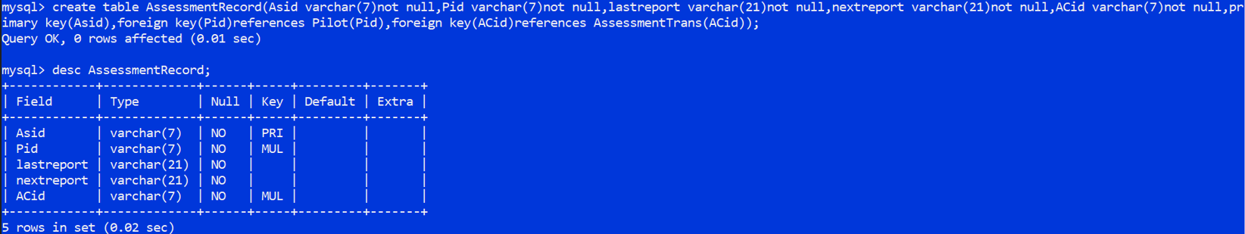

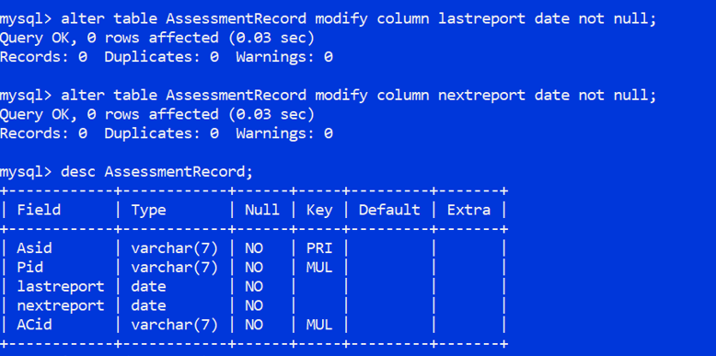

This is the Assessment Record in which it contains five attributes with the primary and Foreign Key. If want to modify its Type its probably welcome as shown in the snapshot.

## 11.Aerofly

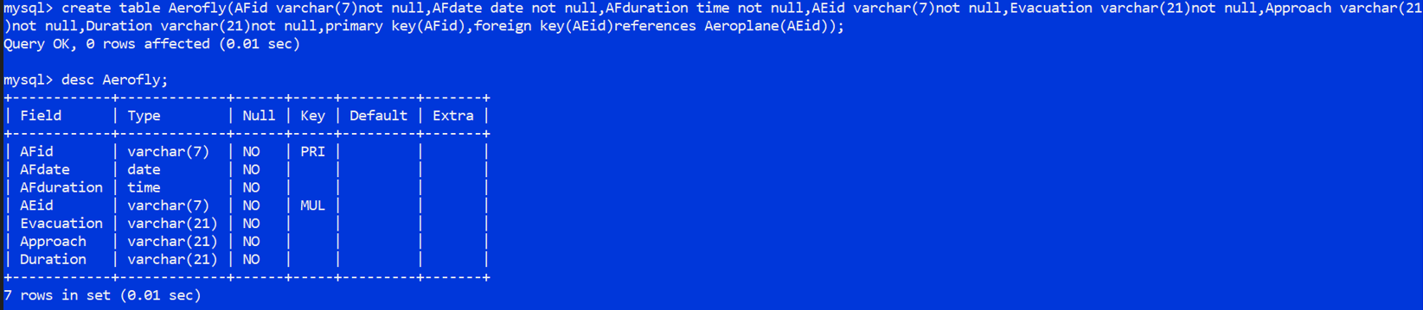

This snapshot consists of Aero fly table creation where create command is used as shown. It consists of 7 attributes with the primary key and foreign key related to it.

## 12.PilotAerofly

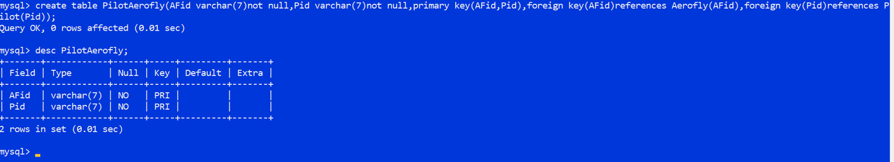

The table consists of Pilot Aero fly Table with two attributes consists of Primary key and foreign key along with it.

# **Data inserting**:

## Inserting Data into Aero plane

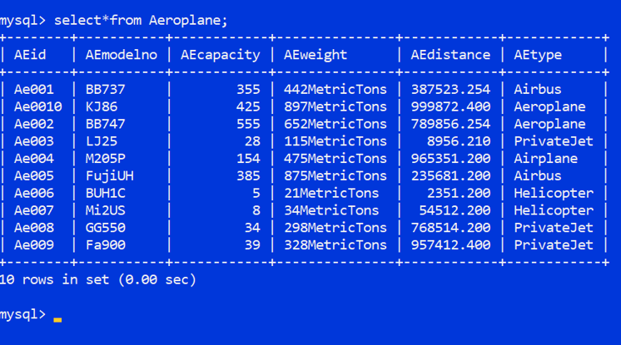

* Aero plane capacity is depended on number of seats in the plane.
* Aero plane weights are described in metric Tons.
* Aero plane distance is calculated in kilometers

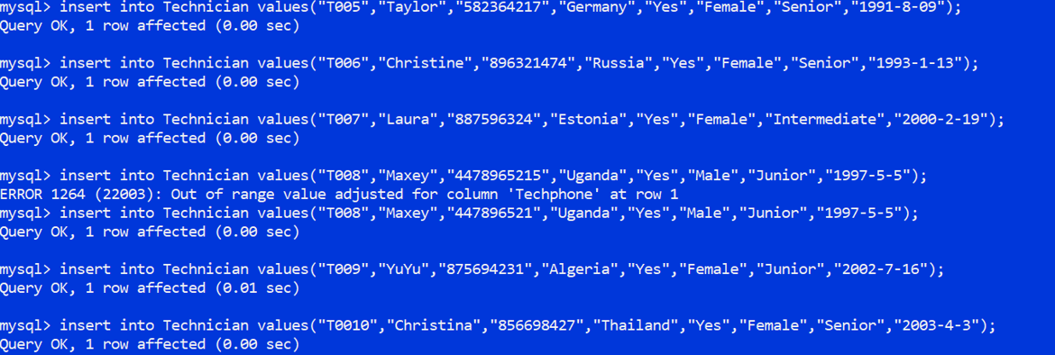

## Inserting Data into Technician Tables

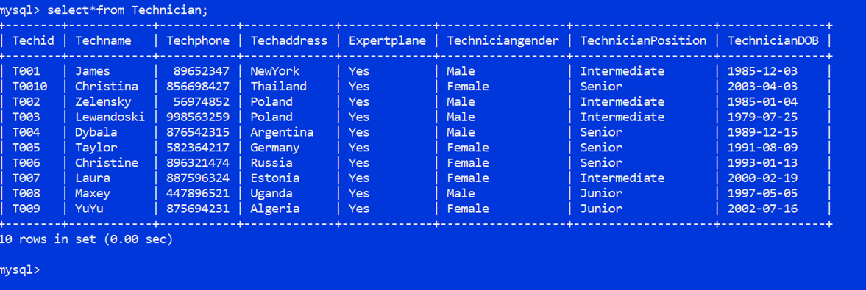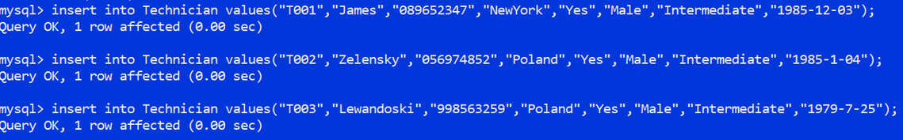

* Technician Phone number is based on Technician Address.
* Technician Position is based on its skills and the Experience…

## Inserting Data into Technician Support Table

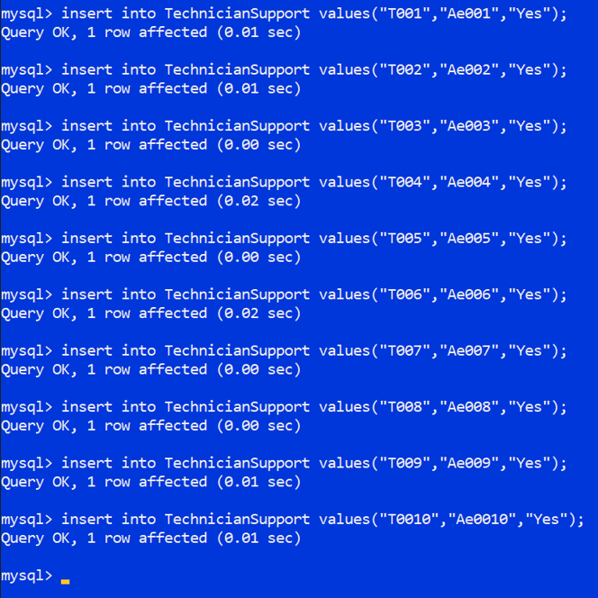

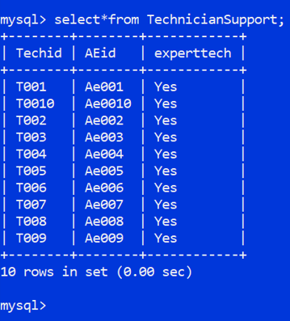

## Inserting Data into M type Table

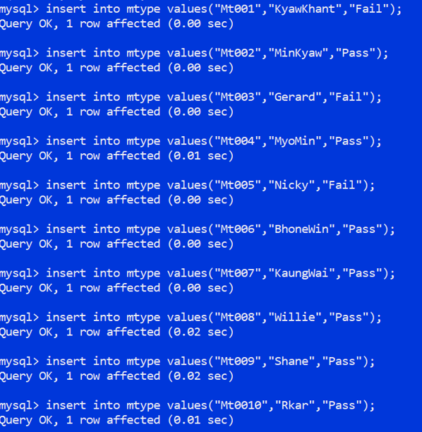

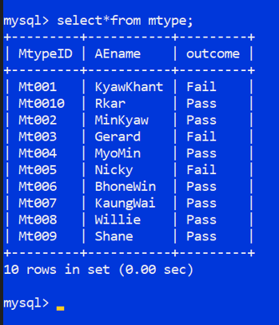

## Inserting Data into Maintenance Table

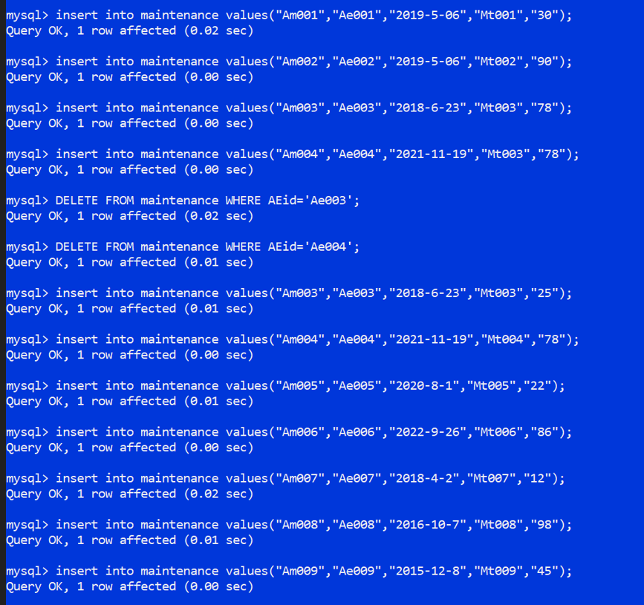

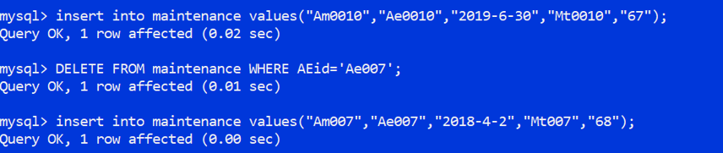

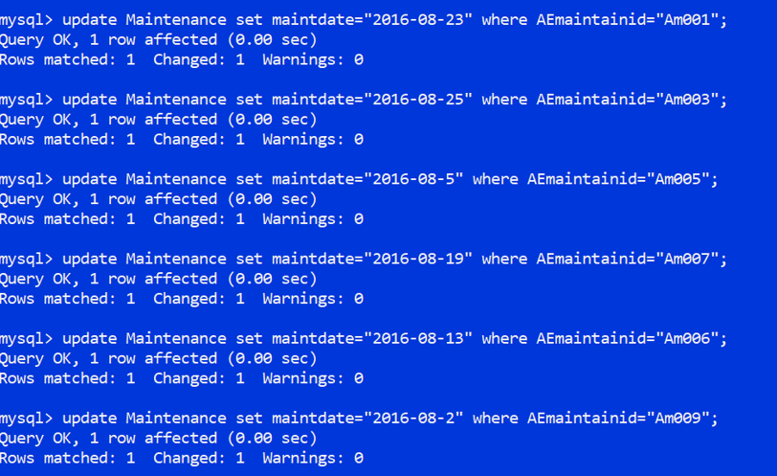

* 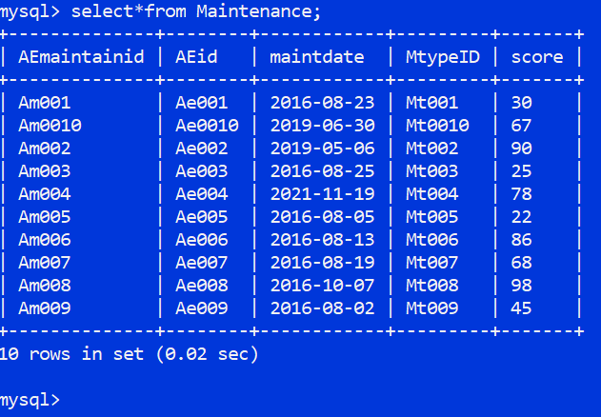Maintenance is filled with primary key along with the foreign key of M type ID.
* The score less than 40 is marked as a failure.
* Whereas the marks above 40 is marked a Pass.

## Inserting Data into Maintenance Technician Table

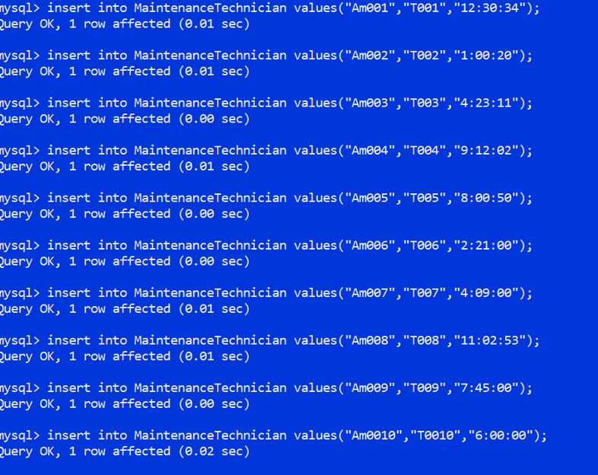

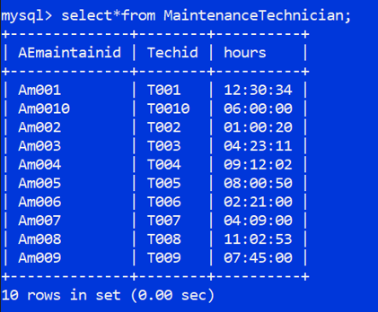

* The time is depended on the standard Greenwich median Time of London.

## Inserting Data into Assessment Type Table

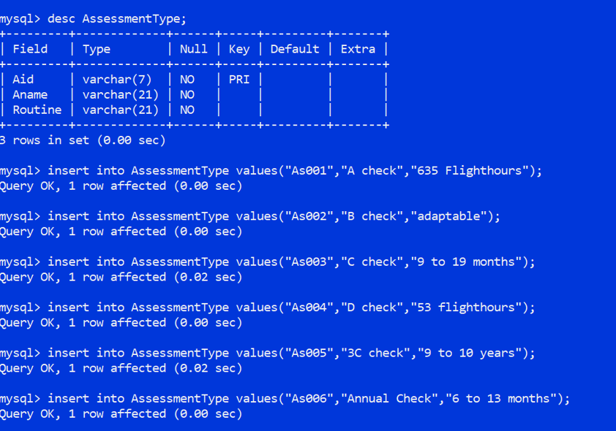

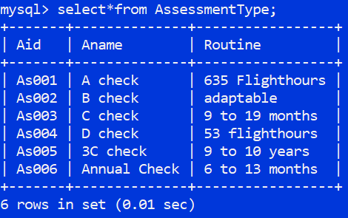

* Assessment Type consists of A, B, C and D check. A type check comprises of a visual assessment of the airframe, engine, avionics, and accessories to determine the aircraft's overall condition.
* B Type check comprise an A check plus chosen operational checks, fluid service and lubrication, and an open examination of the panels and cowlings.
* C Type check comprise an A- and B- check, as well as a complete examination of the airframe, engines, and accessories, heavy lubrication, and a section of the corrosion protection program.
* D Type check involve the removal of cabin contents to allow for a thorough structural evaluation.
* Annual Check consist of all type check where it s to Check all the detail of the Aero plane.

## Inserting Data into Assessment Trans Table

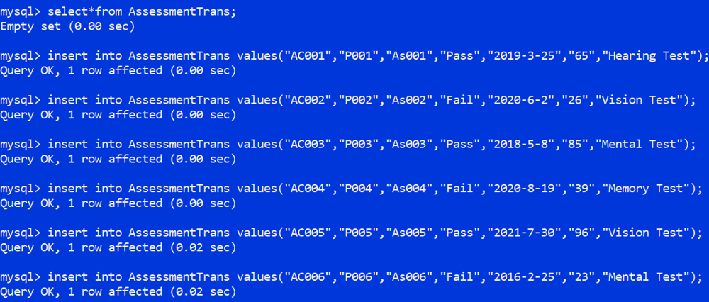

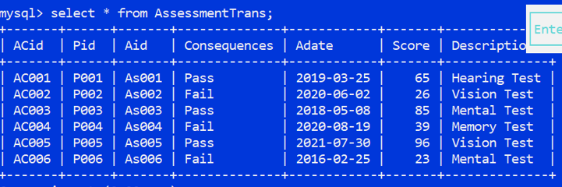

* If the score is less than 40 the result will be failed whereas if the score is more than 40 then the result will be pass.
* The Test is shown in the snapshot.

## Inserting Data into Pilot Table

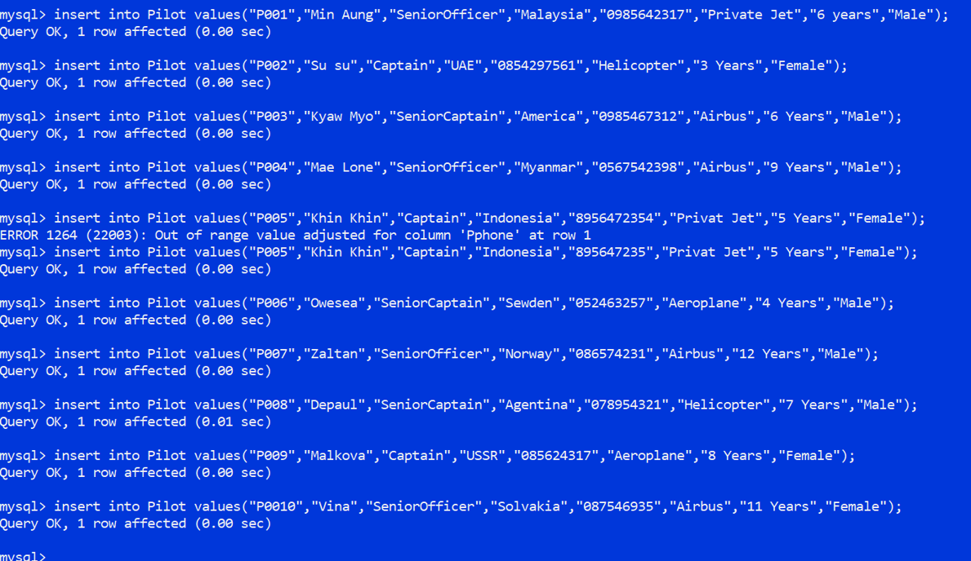

* The Pilot Experience is shown in years.
* The Phone number code is based on the Pilot Address where he/she live as shown in the snapshot.

## Inserting Data into Assessment Record Table

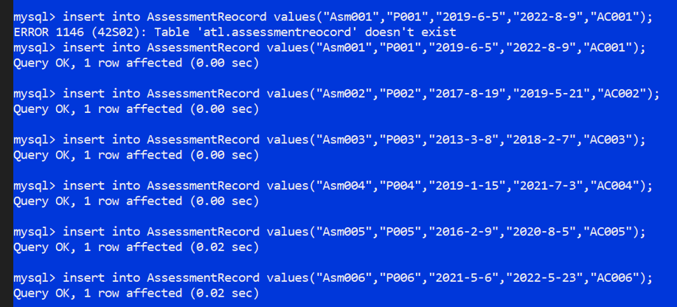

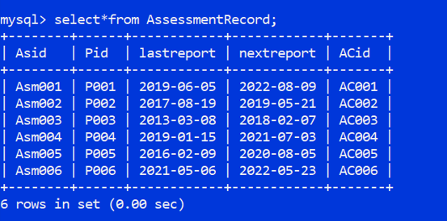

* The last report of Assessment Record is the previous Assessment Transition Record.
* The next report of Assessment Record is the recent Assessment Transition Record.

## Inserting Data into Aero fly Table

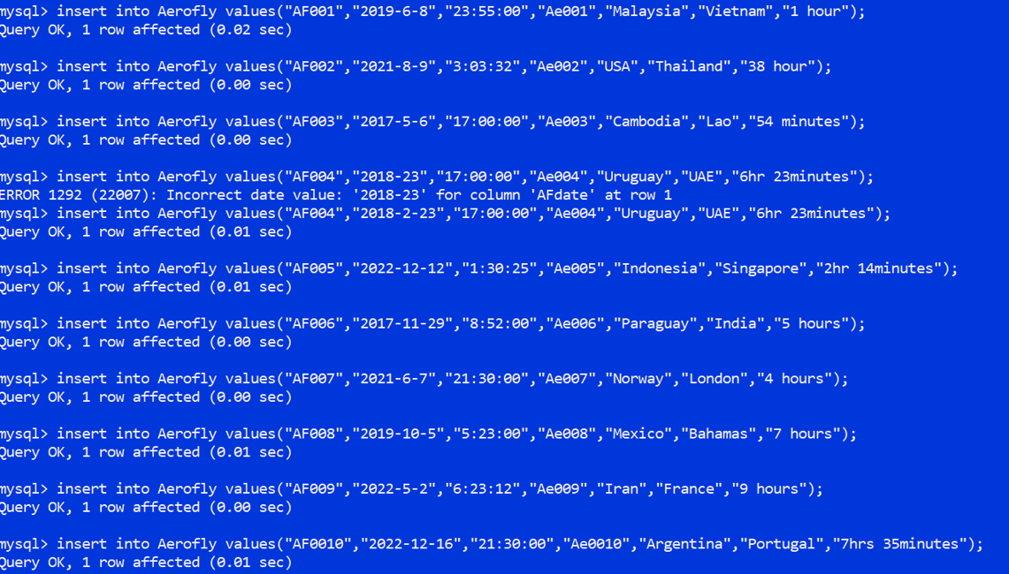

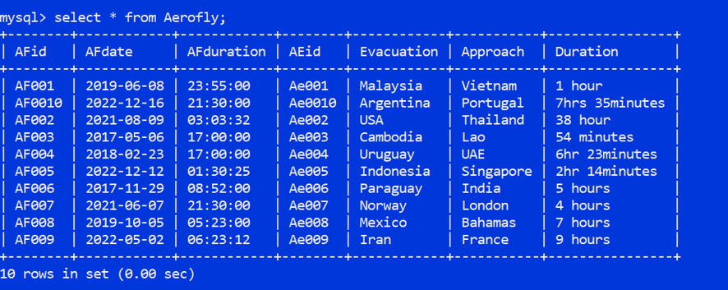

## Inserting Data into Pilot Aero fly Table

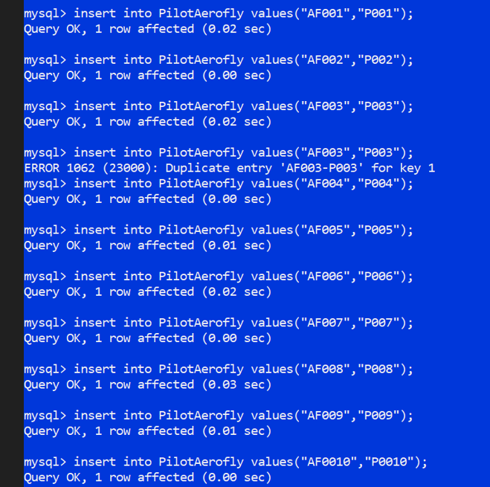

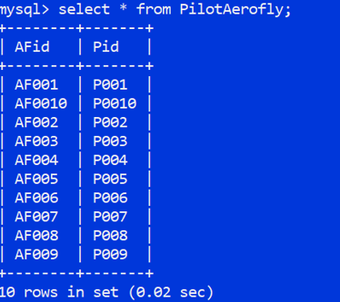

# Data Selection:

Display the Maintenance tests completed in August 2016.

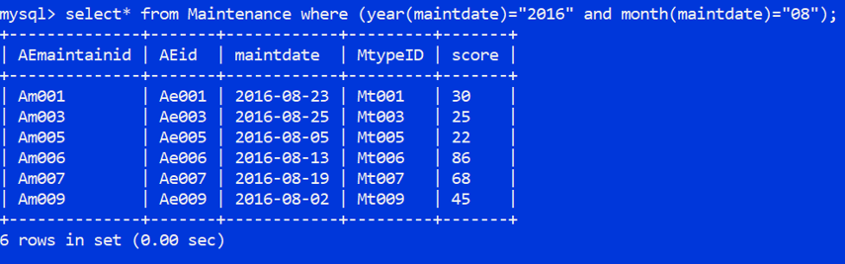

List the output in ascending order depending on the date, followed by the Aero plane information.

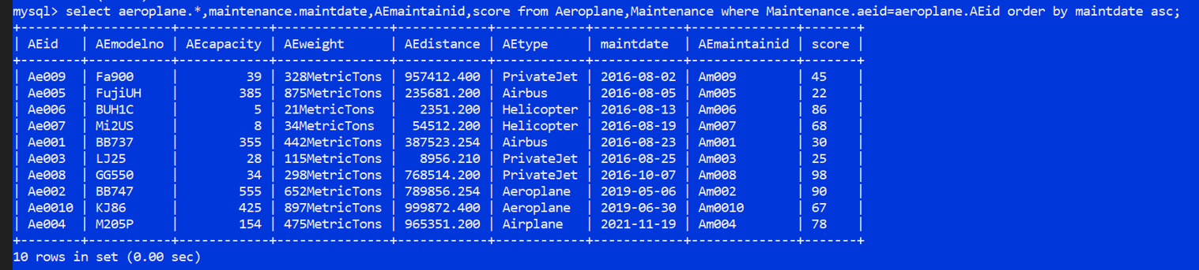

* Weight is equally distributed according to the number of seats.
* A score less than 40 will marked as failure and the score less than 60 will be marked as a Pass.
* Distance is calculated in Kilometers.

# Task 3 – Relational Algebra:

